**How to Update the Firmware**

**Hardware** is the physical part of a micro:bit.

**Software** is made up of the programs you write and run on your micro:bit.

**Firmware** is in the middle: a special kind of software that makes devices function properly. It’s physically stored in the micro:bit’s interface chip and doesn’t change when you write programs or turn your micro:bit off, but it can be updated.

The micro:bit will work with the firmware it came with, but there may be times when you may want to update the firmware to use new features like [WebUSB](https://microbit.org/get-started/user-guide/web-usb/).

### Checking your firmware version

To find out what version of the firmware you have on your micro:bit, **Plug it in via USB**, open up the **DETAILS.TXT** file from the **MICROBIT** drive and look for the number on the line that begins 'Interface Version'. In this example, the firmware version is 0254:

# DAPLink Firmware - see https://mbed.com/daplink

Unique ID: 9904360249624e45004a601400000027000000009796990b

HIC ID: 9796990b

Auto Reset: 1

Automation allowed: 0

Overflow detection: 0

Incompatible image detection: 1

Page erasing: 0

Daplink Mode: Interface

Interface Version: 0254

Bootloader Version: 0254

Git SHA: ec3fec91e815b1fe27cefb8bc4ffa85ca3317502

Local Mods: 0

USB Interfaces: MSD, CDC, HID, WebUSB

Bootloader CRC: 0xdb256cca

Interface CRC: 0xd0f0bacf

Remount count: 0

URL: https://microbit.org/device/?id=9904&v=0254

### How to update the firmware

1. Download the **hex file** from this page to your computer.
2. Down load the latest firmware---0255(we also provide you with it in the folder)

<https://www.microbit.org/get-started/user-guide/firmware/>

Disconnect the USB cable and battery pack from the micro:bit.

Hold the reset button at the back of the micro:bit and plug the USB lead into the micro:bit and a computer. You should see a drive appear in your file manager called **MAINTENANCE** (instead of MICROBIT).

# IMG_256

### The MAINTENANCE drive will look like this, depending on your computer:

### **Windows**

### 

### macOS

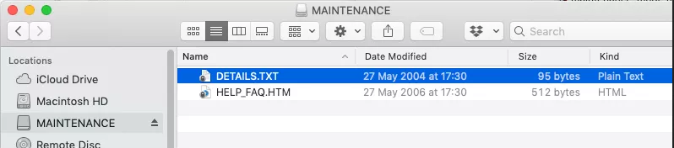

* Download the hex file from this page to your computer.

(in the KS0426 folder)

* Drag and drop the new firmware .HEX file you downloaded from this page onto the **MAINTENANCE** drive and wait for the yellow LED on the back of the device to stop flashing. When the upgrade is completed, the micro:bit will reset, ejecting itself from the computer and re-appear in normal **MICROBIT** drive mode.
* Finally, check the **DETAILS.TXT** file that is on the **MICROBIT** drive and make sure that it has the same version number as the .HEX firmware that you just downloaded and flashed to the interface chip.